Supplementary material

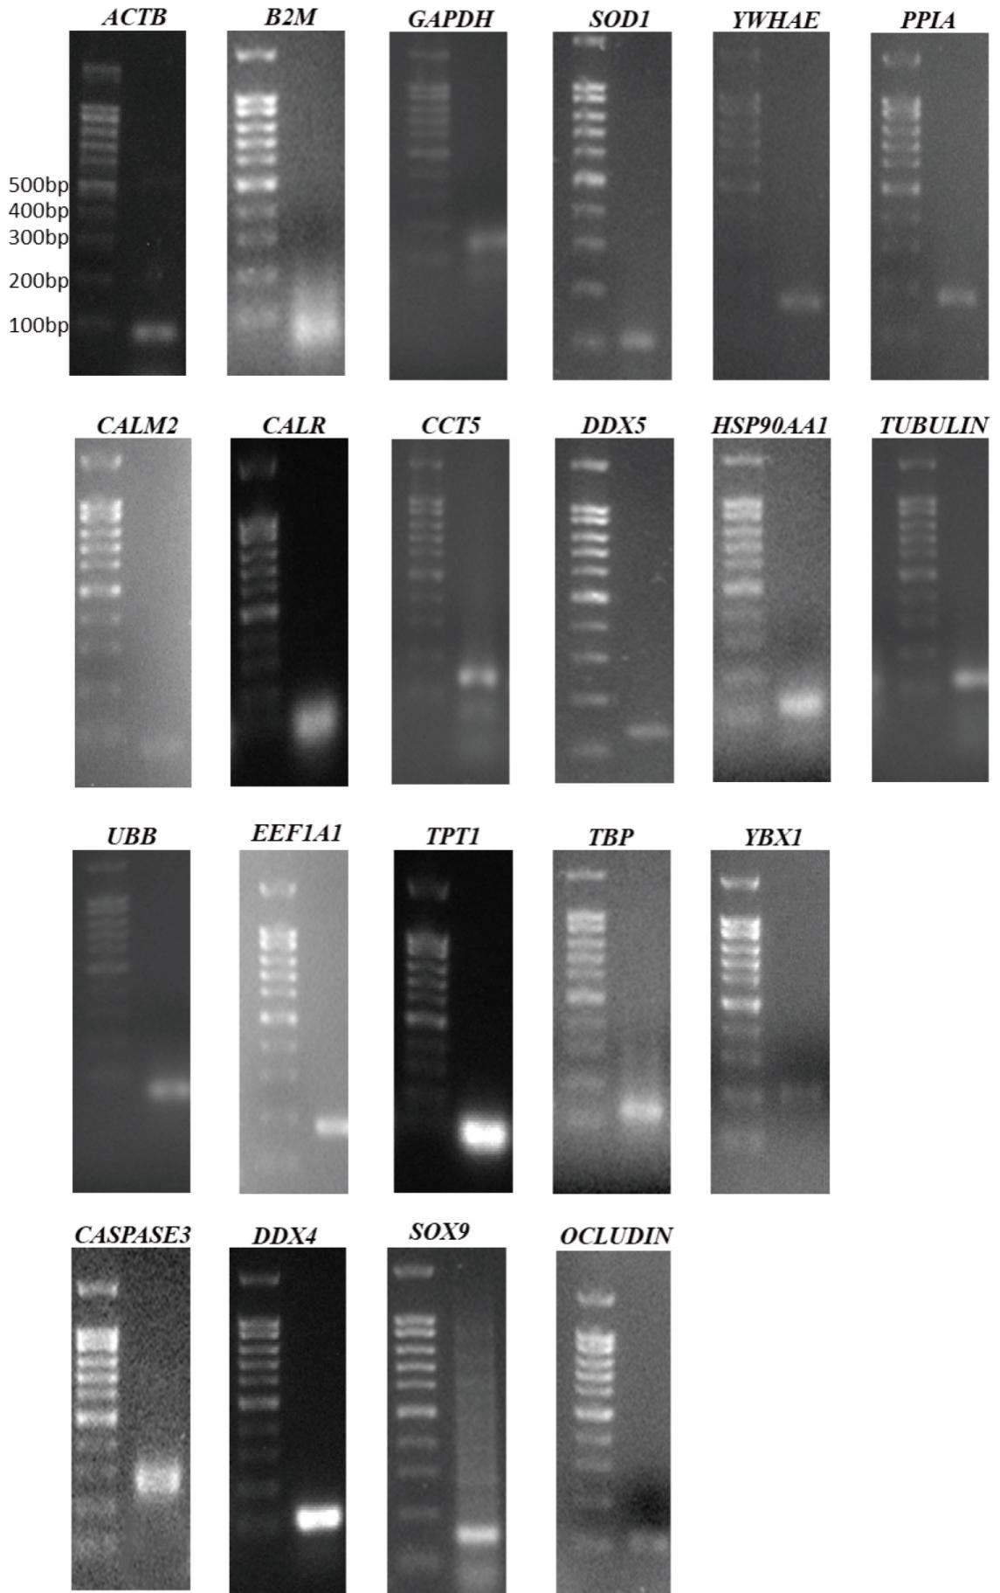
Supplementary Fig. 1. The melting curves of 17 housekeeping genes and 4 target gens. ACTB: Actin Beta; B2M: Beta-2-Microglobulin; CALM2: Calmodulin 2; CALR: Calreticulin; CCT5: Chaperonin Containing TCP1 Subunit 5; DDX5: DEAD-Box Helicase 5; EEF1A1: Eukaryotic Translation Elongation Factor 1 Alpha 1; GAPDH: Glyceraldehyde-3-Phosphate Dehydrogenase; HSP90AA1: Heat Shock Protein 90 Alpha Family Class A Member 1; PPIA: Peptidylprolyl Isomerase A; SOD1: Superoxide dismutase 1; TBP: TATA-Box Binding Protein; TPT1: Tumor Protein Translationally Controlled 1; TUBULIN: Tubulin; UBB: Ubiquitin B; YBX1: Y-box binding protein 1; YWHAE: Tyrosine 3-Monooxygenase/Tryptophan 5-Monooxygenase Activation Protein Zeta; CASPASE3: Cysteine-dependent aspartate-specific protease-3; DDX4: DEAD-Box Helicase 4; SOX9: SRY-box transcription factor 9; OCCLUDIN: Occludin.

Supplementary Table 1. Primer sequences information used in the study.
HKGs and TGs name | NCBI gene ID | Forward primer (Sequence 5′–3′) | Reverse primer (Sequence 5′–3′) | Tm (℃) | Production size (bp) | Efficiency (%)
ACTB | NM_031144.3 | CCCGCGAGTACAACCTTCT | CGTCATCCATGGCGAACT | 57.4 | 72 | 95.3
GAPDH | NM_017008.4 | CTTTGGTATCGTGGAAGGACTC | GTAGAGGCAGGGATGATGTTCT | 58.4 | 132 | 96.0
TUBULIN | NM_139254.2 | CAGATGCTGGCCATTCAGAGTAAG | TGTTGCCGATGAAGGTGGAC | 60.5 | 127 | 96.7
YWHAE | NM_031603.2 | TCTTAATTCCCCCGACCGTG | TTCTGCTCTTCACCATCGCC | 59.4 | 177 | 98.2
B2M | NM_012512.2 | AGCAGGTTCCTCAAACAAGG | TTCTGCCTTGGAGTCCTTTC | 57.4 | 60 | 96.5
HSP90AA1 | NM_175761.2 | TTCCAACTCCTCAGACGCTC | AGGGTTCGGTCTTGCTTGTT | 59.4 | 120 | 95.6
PPIA | NM_017101.1 | AGGATTCATGTGCCAGGGTG | CTCAGTCTTGGCAGTGCAGA | 59.9 | 187 | 98.6
EEF1A1 | NM_175838.2 | TGCTGGAGCCAAGTGCTAAT | GTGCCAATGCCGCCAATTTT | 59.6 | 181 | 97.0
CALM2 | NM_017326.3 | TGGTCGCGTCTCGGAAAC | TCTTTGAATTCTGCAATCTGCTCTT | 59.5 | 78 | 98.1
DDX5 | NM_001007613.1 | AGAGGTCACAACTGTCCAAAACC | CCAATCCACTGAGAGCAACTGG | 60.9 | 145 | 96.4
YBX1 | NM_001416726.1 | GCAGTGTTCATTTCAGGGGC | TGGATCGGCTGCTTTTGTCT | 59.8 | 200 | 95.0
UBB | NM_138895.3 | GGCTTTGTCCGGTTCCGA | GCGATGAAGGAACAAACCGC | 59.9 | 70 | 98.5
SOD1 | NM_017050.1 | CATTGGCCGTACTATGGTGGT | CAATCACACCACAAGCCAAGC | 60.1 | 113 | 96.9
CALR | NM022399.2 | AGTTCTTGGACGGAGATGCC | AATCGGGCATCTTGGCTTGT | 59.7 | 145 | 98.3
TPT1 | NM_053867.2 | ATGACGAGCTGTTCTCCGAC | CTGACCATCTTGCCCTCCAC | 60.4 | 82 | 97.6
CCT5 | NM_001004078.1 | CCCCACTCTGGAACAGTACG | AGGGCAGGGTTAGACTCCTT | 59.7 | 147 | 97.4
TBP | NM_001004198.1 | TGGGATTGTACCACAGCTCCA | CTCATGATGACTGCAGCAAACC | 60.1 | 132 | 96.5
DDX4 | NM_001077647.2 | CAGCATTCCCATTGTGTTAGC | GGCAGTTATTCCATCCCTCATC | 57.8 | 121 | 96.6
CASPASE3 | NM_012922.2 | GGTATTGAGACAGACAGTGG | CATGGGATCTGTTTCTTTGC | 54.9 | 281 | 97.5
OCCLUDIN | NM_031329 | ATGGCTGCTGCTGATGAATA | CTTGATGTGCGATAATTTGCTCTT | 57.4 | 111 | 98.4
SOX9 | NM_080403.2 | GTCGGTGAAGAATGGGCAAG | GACCTGAGATTGCCCGGA | 58.7 | 160 | 95.3
HKGs: Housekeeping Genes; Tm: Melting temperature; ACTB: Actin Beta; B2M: Beta-2-Microglobulin; CALM2: Calmodulin 2; CALR: Calreticulin; CCT5: Chaperonin Containing TCP1 Subunit 5; DDX5: DEAD-Box Helicase 5; EEF1A1: Eukaryotic Translation Elongation Factor 1 Alpha 1; GAPDH: Glyceraldehyde-3-Phosphate Dehydrogenase; HSP90AA1: Heat Shock Protein 90 Alpha Family Class A Member 1; PPIA: Peptidylprolyl Isomerase A; SOD1: Superoxide dismutase 1; TBP: TATA-Box Binding Protein; TPT1: Tumor Protein Translationally Controlled 1; TUBULIN: Tubulin; UBB: Ubiquitin B; YBX1: Y-box binding protein 1; YWHAE: Tyrosine 3-Monooxygenase/Tryptophan 5-Monooxygenase Activation Protein Zeta; CASPASE3: Cysteine-dependent aspartate-specific protease-3; DDX4: DEAD-Box Helicase 4; SOX9: SRY-box transcription factor 9; OCCLUDIN: Occludin.

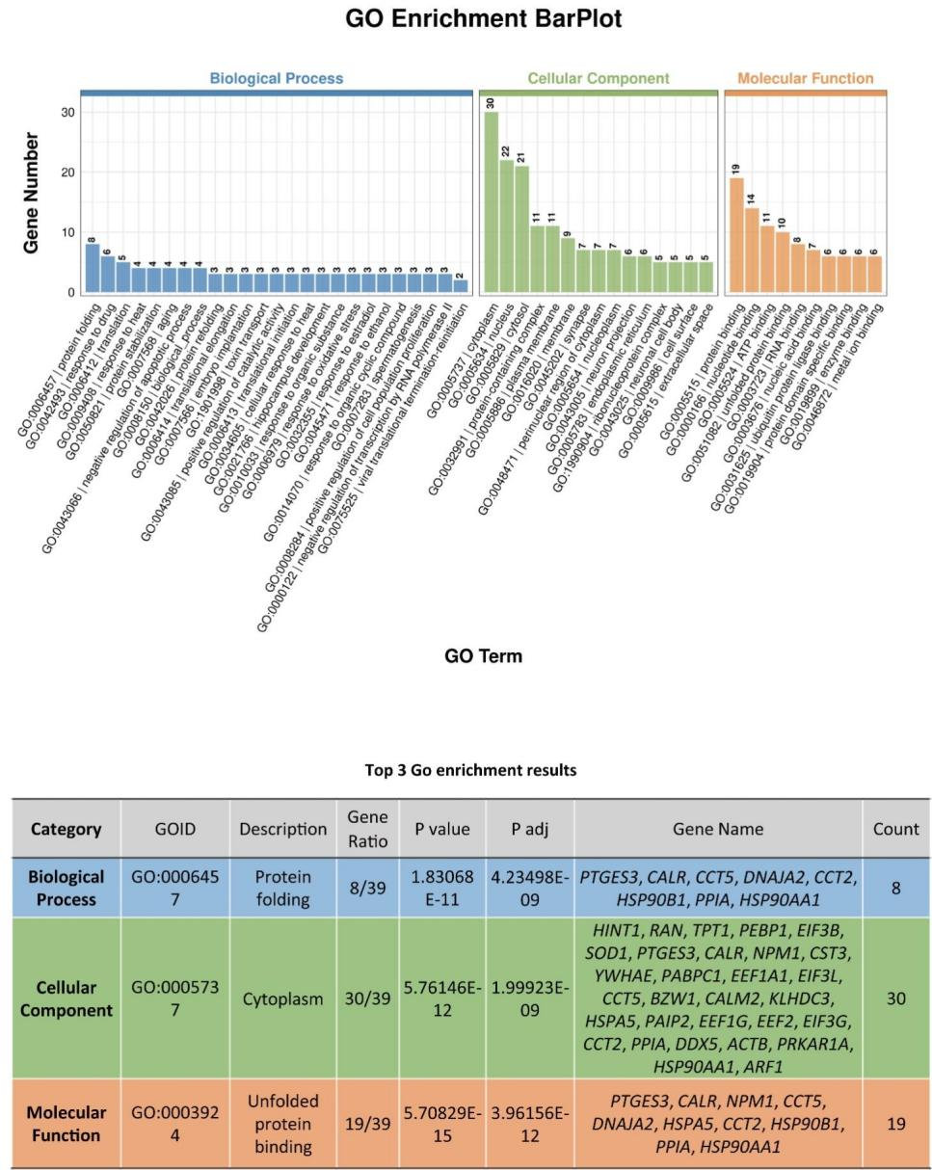
Supplementary Fig. 2. The GO analysis of candidate HKGs in RNA-Sequence data. GO: Gene Ontology‌; PTGES3: prostaglandin E synthase 3; CALR: Calreticulin; CCT5: Chaperonin Containing TCP1 Subunit 5; DNAJA2: DnaJ (Hsp40) homolog subfamily A member 2; CCT2: Chaperonin Containing TCP1 Subunit 2; HSP90B1: Heat Shock Protein 90 Beta Family Member 1; PPIA: Peptidylprolyl Isomerase A; HSP90AA1: Heat Shock Protein 90 Alpha Family Class A Member 1; HINT1: Histidine triad nucleotide-binding protein 1; RAN: RAN member RAS oncogene family; TPT1: Tumor Protein Translationally Controlled 1; PEBP1: phosphatidylethanolamine binding protein 1; EIF3B: eukaryotic translation initiation factor 3 subunit B; SOD1: Superoxide dismutase 1; NPM1: Nucleophosmin 1; CST3: Cystatin C; YWHAE: Tyrosine 3-Monooxygenase/Tryptophan 5-Monooxygenase Activation Protein Zeta; PABPC1: poly(A) binding protein, cytoplasmic 1; EEF1A1: Eukaryotic Translation Elongation Factor 1 Alpha 1; EIF3L: eukaryotic translation initiation factor 3 subunit L; BZW1: Basic Leucine Zipper and W2 Domains 1; CALM2: Calmodulin 2; KLHDC3: kelch domain containing 3; HSPA5: Heat Shock Protein Family A (Hsp70) Member 5; PAIP2: poly(A) binding protein interacting protein 2; EEF1G: eukaryotic translation elongation factor 1 gamma; EEF2: Eukaryotic Translation Elongation Factor 2; EIF3G: eukaryotic translation initiation factor 3 subunit G; DDX5: DEAD-Box Helicase 5; ACTB: Actin Beta; PRKAR1A: Protein Kinase cAMP-Dependent Type I Regulatory Subunit Alpha; ARF1: ADP-ribosylation factor 1.

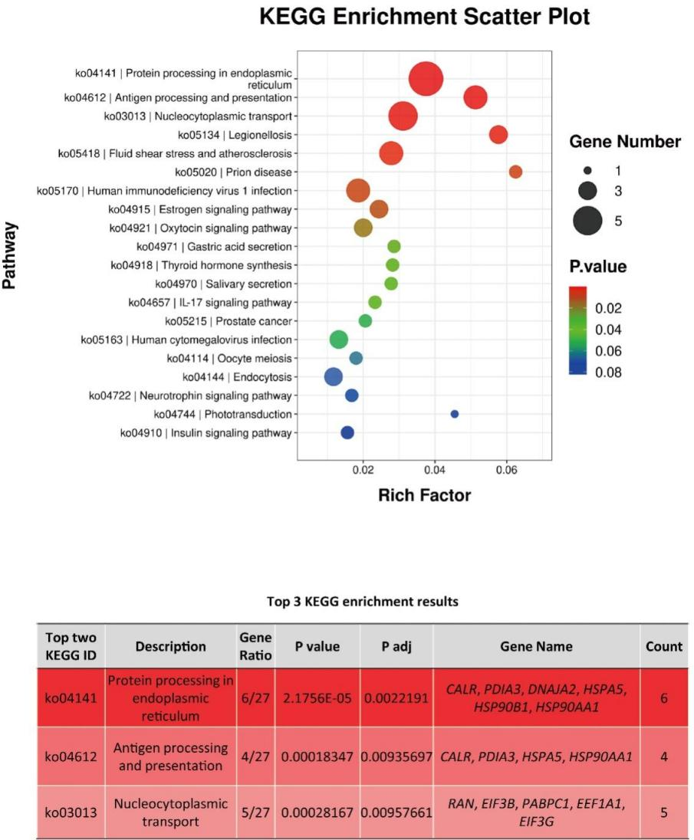
Supplementary Fig. 3. The KEGG enrichment analysis of candidate genes in RNA-Sequence data. KEGG: Kyoto Encyclopedia of Genes and Genomes; CALR: Calreticulin; PDIA3: Protein Disulfide Isomerase Family A, Member 3; DNAJA2: DnaJ (Hsp40) homolog subfamily A member 2; HSPA5: Heat Shock Protein Family A (Hsp70) Member 5; HSP90B1: Heat Shock Protein 90 Beta Family Member 1; HSP90AA1: Heat Shock Protein 90 Alpha Family Class A Member 1; RAN: RAN member RAS oncogene family; EIF3B: eukaryotic translation initiation factor 3 subunit B; PABPC1: poly(A) binding protein, cytoplasmic 1; EEF1A1: Eukaryotic Translation Elongation Factor 1 Alpha 1; EIF3G: eukaryotic translation initiation factor 3 subunit G.

Supplementary Table 2. Ranking and stability values of HKGs calculated by geNorm method.
Testis tissues |  | Sertoli cells |  | Total
HKGs | M value | HKGs | M value | HKGs | M value
YBX1 | 0.586 | ACTB | 0.785 | PPIA | 1.184
EEF1A1 | 0.586 | DDX5 | 0.785 | ACTB | 1.184
PPIA | 0.797 | PPIA | 0.841 | TPT1 | 1.248
DDX5 | 0.971 | UBB | 0.908 | TBP | 1.360
CALM2 | 1.061 | CCT5 | 0.980 | CALR | 1.444
ACTB | 1.128 | HSP90AA1 | 1.037 | DDX5 | 1.553
GAPDH | 1.195 | EEF1A1 | 1.088 | EEF1A1 | 1.681
TBP | 1.272 | YBX1 | 1.148 | YBX1 | 1.770
TPT1 | 1.363 | TBP | 1.196 | SOD1 | 1.828
CALR | 1.419 | CALM2 | 1.233 | GAPDH | 2.015
SOD1 | 1.499 | SOD1 | 1.261 | CALM2 | 2.160
CCT5 | 1.577 | TPT1 | 1.298 | CCT5 | 2.266
B2M | 1.652 | CALR | 1.345 | YWHAE | 2.341
YWHAE | 1.725 | YWHAE | 1.409 | B2M | 2.433
UBB | 1.848 | B2M | 1.459 | UBB | 2.523
HSP90AA1 | 1.949 | GAPDH | 1.530 | TUBULIN | 2.643
TUBULIN | 2.043 | TUBULIN | 1.651 | HSP90AA1 | 2.778
The M value is presented as the stability values parameter through geNorm method.
HKGs: Housekeeping Genes; ACTB: Actin Beta; B2M: Beta-2-Microglobulin; CALM2: Calmodulin 2; CALR: Calreticulin; CCT5: Chaperonin Containing TCP1 Subunit 5; DDX5: DEAD-Box Helicase 5; EEF1A1: Eukaryotic Translation Elongation Factor 1 Alpha 1; GAPDH: Glyceraldehyde-3-Phosphate Dehydrogenase; HSP90AA1: Heat Shock Protein 90 Alpha Family Class A Member 1; PPIA: Peptidylprolyl Isomerase A; SOD1: Superoxide dismutase 1; TBP: TATA-Box Binding Protein; TPT1: Tumor Protein Translationally Controlled 1; TUBULIN: Tubulin; UBB: Ubiquitin B; YBX1: Y-box binding protein 1; YWHAE: Tyrosine 3-Monooxygenase/Tryptophan 5-Monooxygenase Activation Protein Zeta.

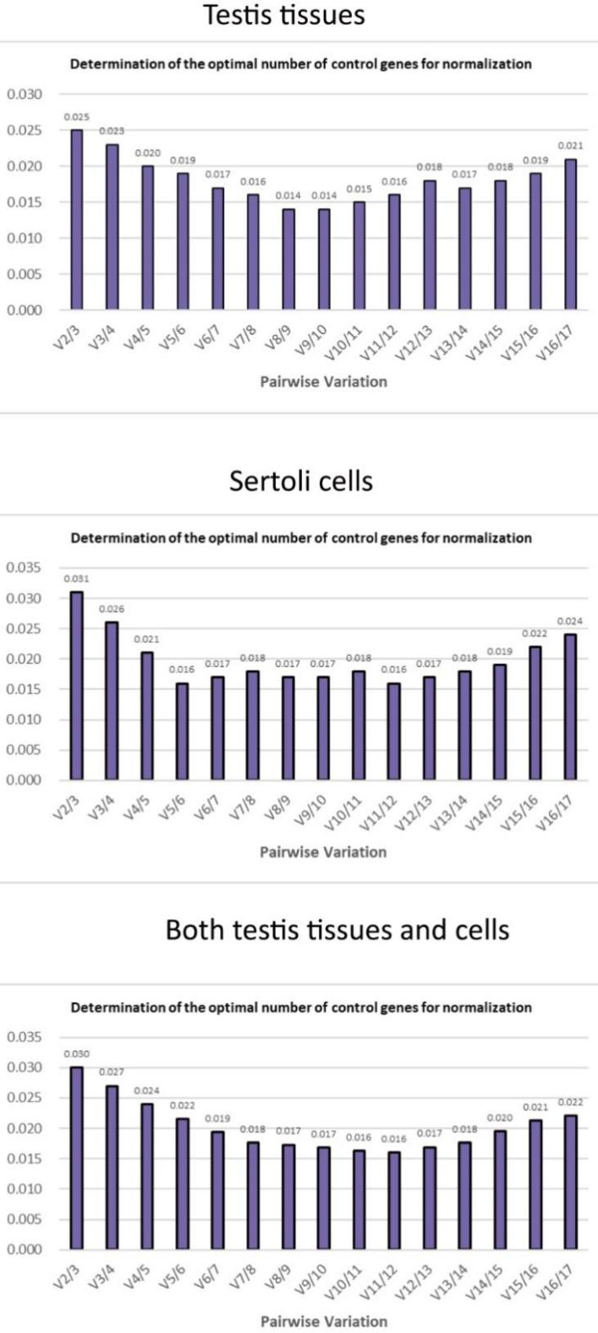
Supplementary Fig. 4. The determination of the suitable number of 17 reference HKGs in testis tissues and Sertoli cells. Vn/Vn+1 (usually abbreviated as V2, V3, etc.) represents the degree of variation in the normalization factor (NF) after adding the n+1th internal reference gene.

Supplementary Table 3. Ranking and stability values of HKGs calculated by Normfinder method.
Testis tissues |  | Sertoli cells |  | Total
HKGs | Stable value | HKGs | Stable value | HKGs | Stable value
PPIA | 0.829 | PPIA | 0.593 | PPIA | 0.726
YBX1 | 0.849 | ACTB | 0.699 | ACTB | 0.882
TBP | 0.867 | UBB | 0.760 | TBP | 0.899
EEF1A1 | 0.975 | DDX5 | 0.843 | SOD1 | 1.197
ACTB | 1.037 | CCT5 | 0.844 | TPT1 | 1.312
DDX5 | 1.052 | HSP90AA1 | 0.879 | CCT5 | 1.417
SOD1 | 1.177 | EEF1A1 | 1.013 | CALR | 1.515
CALM2 | 1.244 | TBP | 1.049 | DDX5 | 1.536
TPT1 | 1.432 | YBX1 | 1.063 | GAPDH | 1.625
GAPDH | 1.444 | CALM2 | 1.220 | EEF1A1 | 1.885
CCT5 | 1.491 | TPT1 | 1.235 | YBX1 | 1.900
CALR | 1.553 | SOD1 | 1.296 | YWHAE | 2.067
B2M | 1.574 | CALR | 1.515 | B2M | 2.104
YWHAE | 1.782 | YWHAE | 1.517 | UBB | 2.135
UBB | 2.209 | B2M | 1.604 | CALM2 | 2.309
TUBULIN | 2.362 | GAPDH | 1.898 | TUBULIN | 2.350
HSP90AA1 | 2.376 | TUBULIN | 2.425 | HSP90AA1 | 2.622
The standard deviation is presented as the stability values parameter through Normfinder method.
HKGs: Housekeeping Genes; ACTB: Actin Beta; B2M: Beta-2-Microglobulin; CALM2: Calmodulin 2; CALR: Calreticulin; CCT5: Chaperonin Containing TCP1 Subunit 5; DDX5: DEAD-Box Helicase 5; EEF1A1: Eukaryotic Translation Elongation Factor 1 Alpha 1; GAPDH: Glyceraldehyde-3-Phosphate Dehydrogenase; HSP90AA1: Heat Shock Protein 90 Alpha Family Class A Member 1; PPIA: Peptidylprolyl Isomerase A; SOD1: Superoxide dismutase 1; TBP: TATA-Box Binding Protein; TPT1: Tumor Protein Translationally Controlled 1; TUBULIN: Tubulin; UBB: Ubiquitin B; YBX1: Y-box binding protein 1; YWHAE: Tyrosine 3-Monooxygenase/Tryptophan 5-Monooxygenase Activation Protein Zeta.

Supplementary Table 4. Ranking and stability values of HKGs calculated by Bestkeeper method.
Testis tissues |  | Sertoli cells |  | Total
HKGs | Stable value | HKGs | Stable value | HKGs | Stable value
PPIA | 0.66 | PPIA | 0.66 | PPIA | 0.68
DDX5 | 0.72 | DDX5 | 0.72 | ACTB | 0.73
YBX1 | 0.76 | YBX1 | 0.76 | TBP | 0.88
ACTB | 0.79 | ACTB | 0.79 | TPT1 | 1.23
EEF1A1 | 0.87 | EEF1A1 | 0.87 | CCT5 | 1.26
TBP | 1.05 | TBP | 1.05 | SOD1 | 1.28
CALM2 | 1.05 | CALM2 | 1.05 | DDX5 | 1.28
GAPDH | 1.05 | GAPDH | 1.05 | GAPDH | 1.30
CALR | 1.28 | CALR | 1.28 | CALR | 1.33
TPT1 | 1.32 | TPT1 | 1.32 | YWHAE | 1.62
SOD1 | 1.37 | SOD1 | 1.37 | YBX1 | 1.67
CCT5 | 1.44 | CCT5 | 1.44 | EEF1A1 | 1.70
B2M | 1.64 | B2M | 1.64 | UBB | 1.86
YWHAE | 1.68 | YWHAE | 1.68 | B2M | 1.89
TUBULIN | 2.01 | TUBULIN | 2.01 | CALM2 | 1.97
HSP90AA1 | 2.09 | HSP90AA1 | 2.09 | TUBULIN | 1.97
UBB | 2.18 | UBB | 2.18 | HSP90AA1 | 2.24
The standard deviation is presented as the stability values parameter through Bestkeeper method.
HKGs: Housekeeping Genes; ACTB: Actin Beta; B2M: Beta-2-Microglobulin; CALM2: Calmodulin 2; CALR: Calreticulin; CCT5: Chaperonin Containing TCP1 Subunit 5; DDX5: DEAD-Box Helicase 5; EEF1A1: Eukaryotic Translation Elongation Factor 1 Alpha 1; GAPDH: Glyceraldehyde-3-Phosphate Dehydrogenase; HSP90AA1: Heat Shock Protein 90 Alpha Family Class A Member 1; PPIA: Peptidylprolyl Isomerase A; SOD1: Superoxide dismutase 1; TBP: TATA-Box Binding Protein; TPT1: Tumor Protein Translationally Controlled 1; TUBULIN: Tubulin; UBB: Ubiquitin B; YBX1: Y-box binding protein 1; YWHAE: Tyrosine 3-Monooxygenase/Tryptophan 5-Monooxygenase Activation Protein Zeta.

Supplementary Table 5. Ranking and stability values of HKGs calculated by Delta Ct method.
Testis tissues |  | Sertoli cells |  | Total
HKGs | Stable value | HKGs | Stable value | HKGs | Stable value
YBX1 | 1.65 | PPIA | 1.40 | PPIA | 1.90
PPIA | 1.66 | ACTB | 1.44 | ACTB | 1.96
EEF1A1 | 1.71 | UBB | 1.46 | TBP | 1.97
TBP | 1.73 | DDX5 | 1.5 | SOD1 | 2.12
DDX5 | 1.77 | HSP90AA1 | 1.51 | TPT1 | 2.15
ACTB | 1.77 | CCT5 | 1.52 | CCT5 | 2.23
CALM2 | 1.85 | EEF1A1 | 1.61 | DDX5 | 2.24
SOD1 | 1.89 | TBP | 1.63 | CALR | 2.27
GAPDH | 2.01 | YBX1 | 1.64 | GAPDH | 2.35
TPT1 | 2.03 | CALM2 | 1.71 | YBX1 | 2.44
CALR | 2.07 | TPT1 | 1.73 | EEF1A1 | 2.45
CCT5 | 2.08 | SOD1 | 1.76 | YWHAE | 2.64
B2M | 2.15 | YWHAE | 1.93 | B2M | 2.65
YWHAE | 2.30 | CALR | 1.93 | UBB | 2.68
UBB | 2.63 | B2M | 1.97 | CALM2 | 2.74
HSP90AA1 | 2.72 | GAPDH | 2.22 | TUBULIN | 2.89
TUBULIN | 2.75 | TUBULIN | 2.65 | HSP90AA1 | 3.03
The standard deviation is presented as the stability values parameter through Delta Ct method.
HKGs: Housekeeping Genes Ct: Cycle threshold; ACTB: Actin Beta; B2M: Beta-2-Microglobulin; CALM2: Calmodulin 2; CALR: Calreticulin; CCT5: Chaperonin Containing TCP1 Subunit 5; DDX5: DEAD-Box Helicase 5; EEF1A1: Eukaryotic Translation Elongation Factor 1 Alpha 1; GAPDH: Glyceraldehyde-3-Phosphate Dehydrogenase; HSP90AA1: Heat Shock Protein 90 Alpha Family Class A Member 1; PPIA: Peptidylprolyl Isomerase A; SOD1: Superoxide dismutase 1; TBP: TATA-Box Binding Protein; TPT1: Tumor Protein Translationally Controlled 1; TUBULIN: Tubulin; UBB: Ubiquitin B; YBX1: Y-box binding protein 1; YWHAE: Tyrosine 3-Monooxygenase/Tryptophan 5-Monooxygenase Activation Protein Zeta.

